Municipal Development Plan: Comprehensive Review and Update
The Village of Beiseker is working with Palliser Regional Municipal Services (PRMS) in a comprehensive review and update of the Village’s Municipal Development Plan (MDP) in collaboration with the Village Council and its residents. The new MDP will replace the current MDP Bylaw 02-2013. Municipalities typically perform a comprehensive review of their MDP’s every ten years to ensure that background information is current to support the policy directions.
What is an MDP?
The MDP is a high-level plan that guides and directs the framework for future growth, land use and development towards the long-term vision of the community. An MDP is a statutory plan, and the provincial government requires all municipalities in Alberta to adopt an MDP by bylaw. As a statutory plan, the Village is required to follow its policy statements in the MDP when making any planning and development decisions.
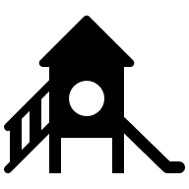
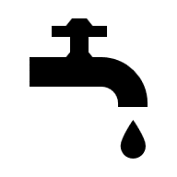




The MDP considers the current and future needs of the community, including housing, commercial goods and services, transportation and utility systems, economic development opportunities, and municipal services like parks and recreation.
What is the goal of the MDP comprehensive review process?
The MDP review process will confirm the Village’s vision for the next 20-30 years and explore the tools and strategies it needs to get there. The new MDP will serve as a relevant and effective tool in guiding land use decisions, supporting long-term community goals, coordinating development with municipal infrastructure and addressing current and emerging issues. The new MDP will be concise, accessible, transparent and easy to interpret.
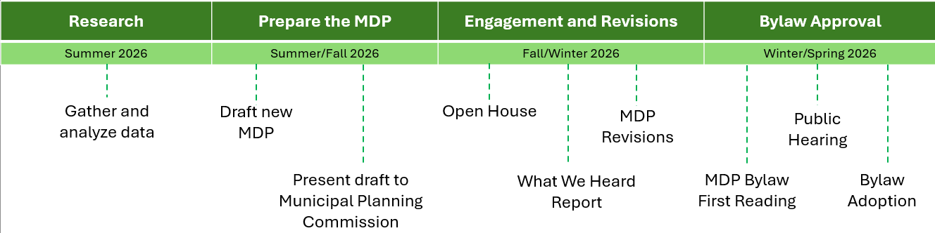
What is the review process and timelines?

View the MDP review Terms of Reference for more information.
The new MDP must comply with provincial requirements of the Municipal Government Act [see Section 632(3) and 636(1)].
How can you be involved?
You will have multiple opportunities to contribute to the new MDP.
Event | What it entails | Date and Location
Open House | The draft MDP will be available for public viewing. Planners and Village Administration will be available to answer questions and hear your feedback. A What We Heard Report will be prepared of all feedback collected. | Fall/Winter 2026 – TBD.
Public Hearing | When adopting a new MDP by bylaw, the Town Council must hold a public hearing before second reading of the bylaw. For more information on public hearings, click here. | Spring 2026 – TBD.

Contact Us
If you have any additional questions or comments please contact:
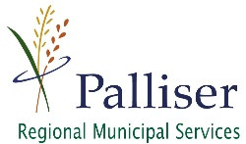
Tracy Woitenko, Senior Planner
twoitenko@palliserservices.ca
877-854-3371

